Get an instant quote: Regular house cleaning
- 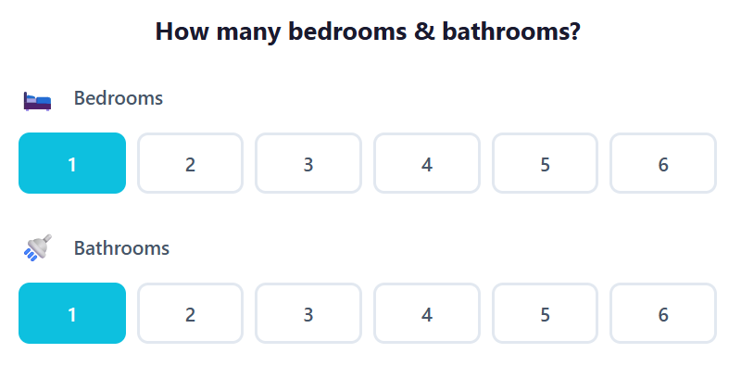
- (Tambahkan di section How many bedrooms and bathrooms) custom clean

Eg. I just need 2 bathrooms, kitchen, and living areas. No bedrooms

(Tambahkan di step berikutnya)
Are you flexible with day and time?
Yes I am flexible (thick )
Mon / Tue / Wed/ Thu/ Fri/ Sat
8am – 12pm / 12 – 3pm / 3 -6pm
Get an instant quote: End of Lease cleaning

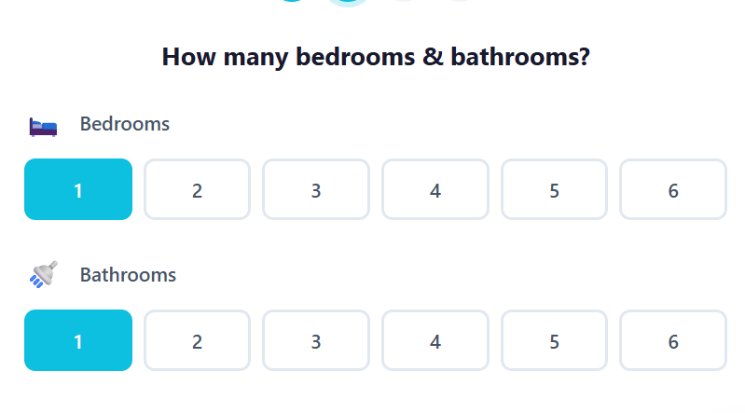
how many storeys do you have?
1 / 2 / 3 / 4

Are you flexible with date and time?
Date: from (date – yang bisa dipilih secara putar) to (date – yang bisa dipilih secara putar) (Month – yang bisa dipilih secara putar)
8am – 12pm / 12 – 3pm / 3 -6pm
Flexible with time (checklist)

Do you need a deep clean on:
- Bathrooms (mould and soap scums)
- Kitchen (oil and grease)
- Oven inside (grease)
- Floors (stains and pet hairs)

Can you send us picture of your shower glass, bathrooms tiles (especially mould and soap scum), kitchen (grease and oily), oven inside, and floors? Just to make sure the state of house condition.
Attach picture

Add on clean:
- Outside windows ---- 
- Fridge inside 
- Garage clean 
- Spots on the walls 
- Microwave Inside 
- Blind clean 

Get an instant quote: Office cleaning
How many rooms
- Small size room (4x4 meter or less) 
- Medium size room (6x6 meter)? 
- Big size room (8x8 or more)? 

How many desks approximately do you have? 

How many bathrooms/toilet? 

How many kitchen/pantry? 

Are you flexible with day and time?

- Yes I am flexible (thick )
- Mon / Tue / Wed/ Thu/ Fri/ Sat/ Sun
- Need during office hours (thick)
- Need after office hours (thick)

